**Force on a Wire**

1. 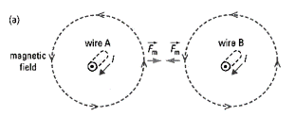Explain why the following two wires *attract*.
2. Explain why the following two wires *repel*.

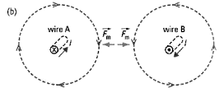

1. Explain why the following wire experiences a force.

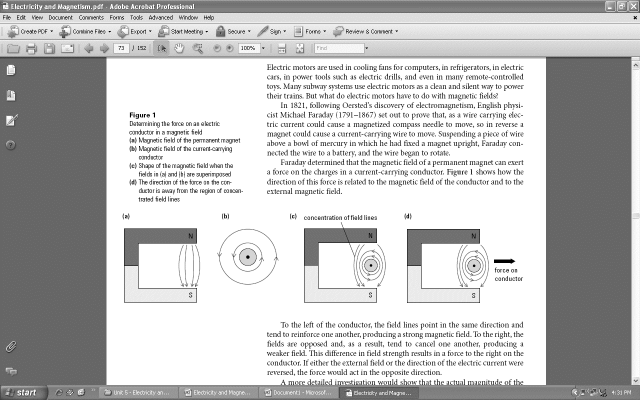

**Motor Principle**

1. Summarize the motor principle below:
2. List three factors that affect the magnitude of the magnetic force:

1. Summarize the Right Hand Rule for Magnetic Force as follows:
   1. Your Thumb points in the direction of:
   2. Your Fingers points in the direction of:
   3. Your Palm points in the direction of:

1. Draw a diagram showing how to use the right hand rule for Magnetic Force.

**Applications of Right Hand Rule #3**

1. Complete the following diagrams to show the direction of the force:

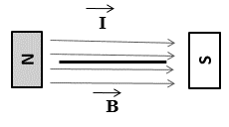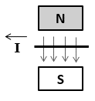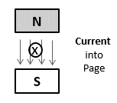

1. Predict the direction of force for the following wires:  
     
   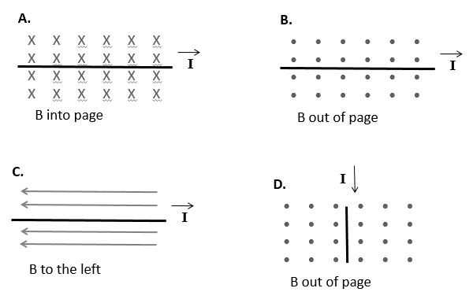
2. Predict the direction of force for the following wire loops:

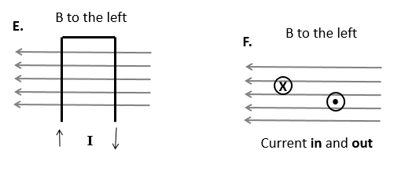

**Motors & Generators**

1. Define the following components of a Simple DC Motor. Clearly label the diagram.  
   1. 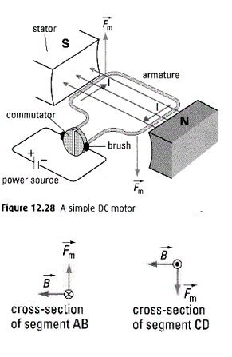Stator:
   2. Armature:
   3. Commutator:
   4. Brushes

1. 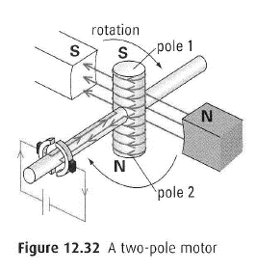Explain how a Two Pole Motor works by combining today’s lesson with the Right Hand Rule for Solenoids.
2. Explain what would happen to the Two Pole Motor if the commutator did not reverse the direction of current each ½ spin.